Cinema Management System

By : **Hiba ALkurd 11717489**

**Dania Shukry 11642770**

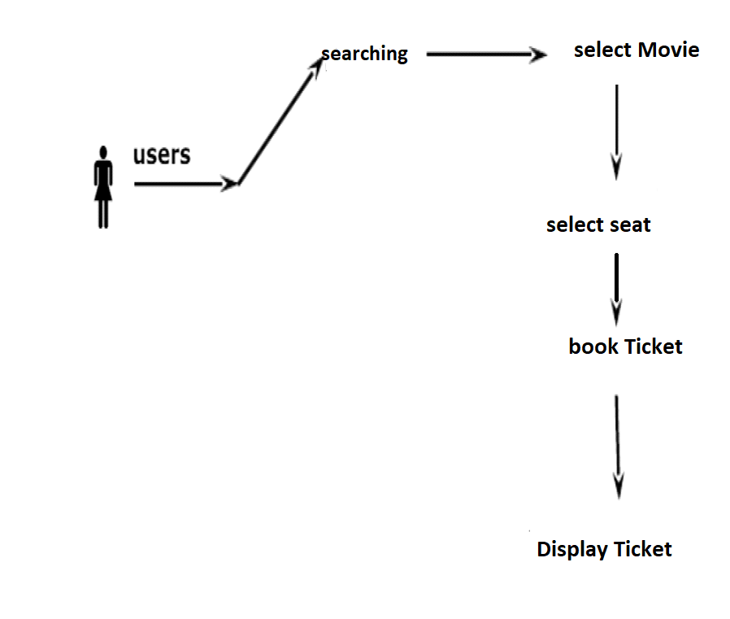

**Abstract**

We designed a program that uses Oracle’s database, to manage records about movie tickets, it provides a friendly interface for both the user and the admin to enter, retrieve and manage records through tables, form queries and reports. .  
**Introduction:**Our cinema management system displays the necessary information about movies and their shows’ schedules for the user. Moreover it helps the admin to easily update or delete information through various attributes and properties that help to maintain and manage records through this software like Movie ID, Name, Show ID, Date, Time, Ticket price.

**About This Project**

This project manages theater tickets booking, it allows users to check for available seats and book them at the same time, so users can make prior bookings for desired seats for their desired show at desired time and cost easily.

Moreover, it gives easy access and view to booked seats and show times, and direct control to adding, removing and updating movies and shows.

The system’s UML diagram consists of six classes, starting with the customer class, it has the following attributes: (unique) username, password, first name, last name, email, phone number. The customer can sign up, log in, log out and book tickets.

A customer can buy one or more tickets each ticket has its own id, seat number, movie’s name, the show’s time and date.

There’s also the Theater class that has a unique number, the admin can add one or more theaters to the data base. Each theater has a number of seats with minimum of 35, each seat has the theater’s no. , type (gold, standard), state (booked, empty) and a number that specifies its position in the theater, you can check if the seat is booked or not and you can add seats or remove them.

A theater also has many shows; each show has a number, start time, end time, date, movie’s name and the theater’s number.

You can have many shows for a movie; a movie class contains the movie’s name, Id, show’s number, genre, rating, trailer, movie’s poster and a brief description of the movie.

**UML diagram**

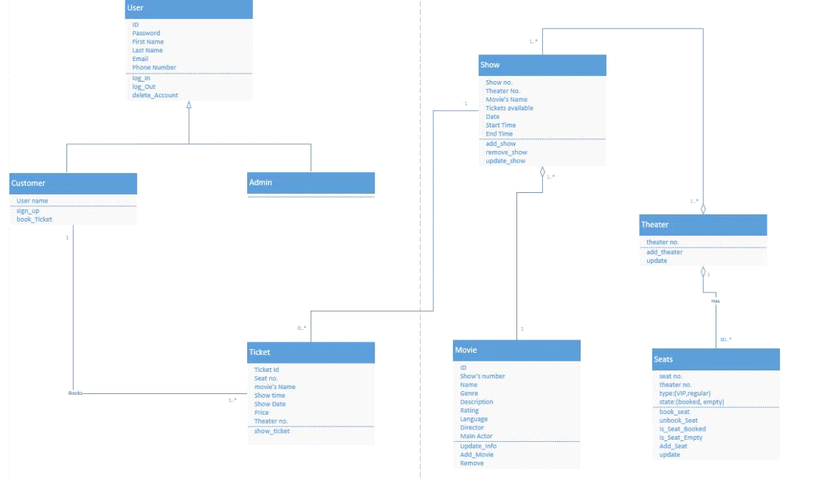

**DataBase Tables**

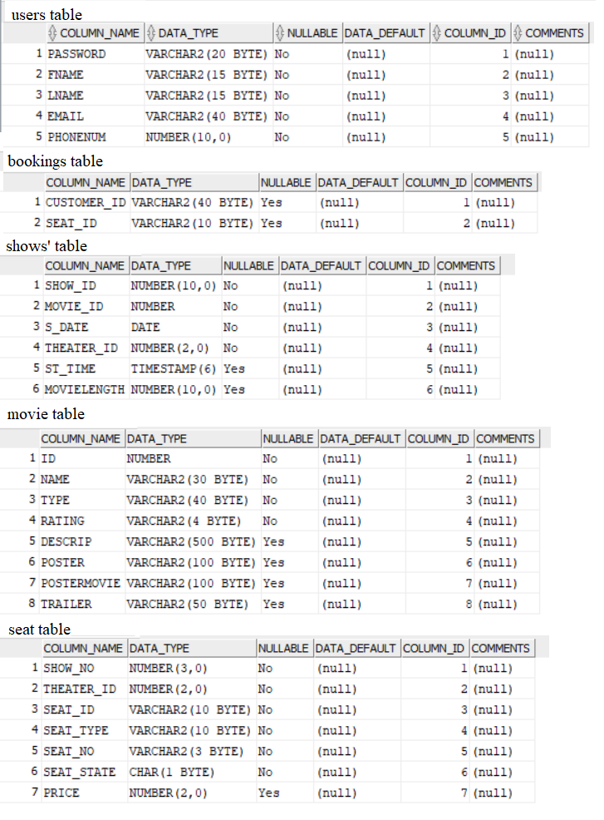

**This project contains two modules**

* Admin
* User

1. **Admin:**

 In this module, administrator can add and delete movies to registered theaters, as well as show times, the administrator can also view bookings through tables in each theater and can easily delete or book seats for customers who don’t use the program.

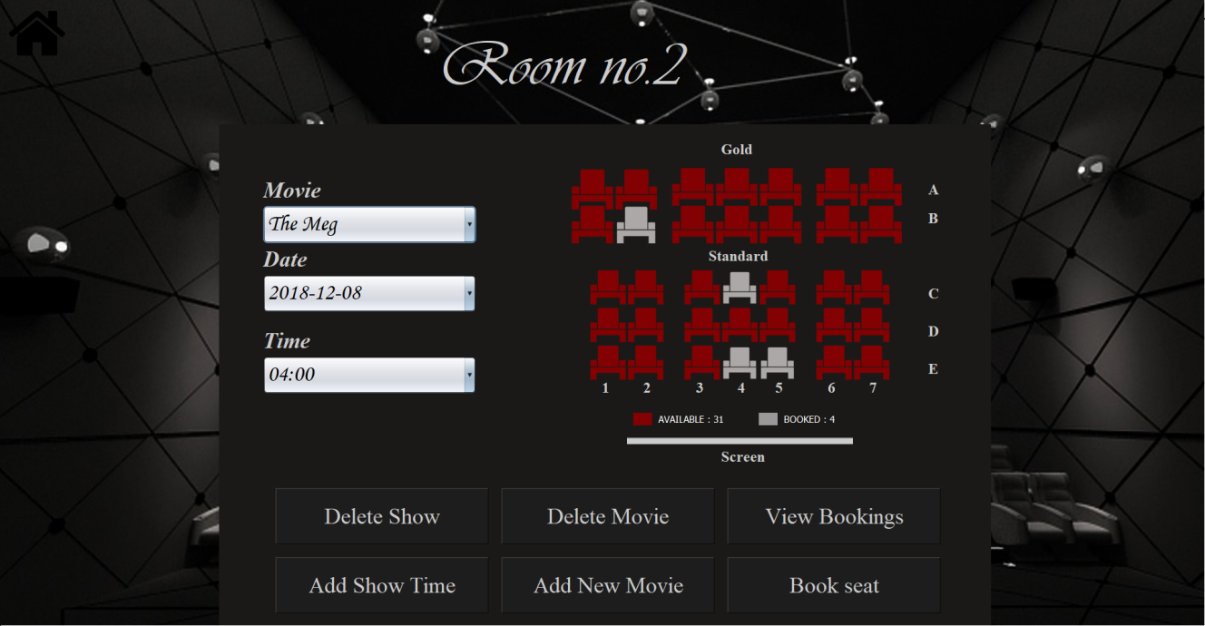

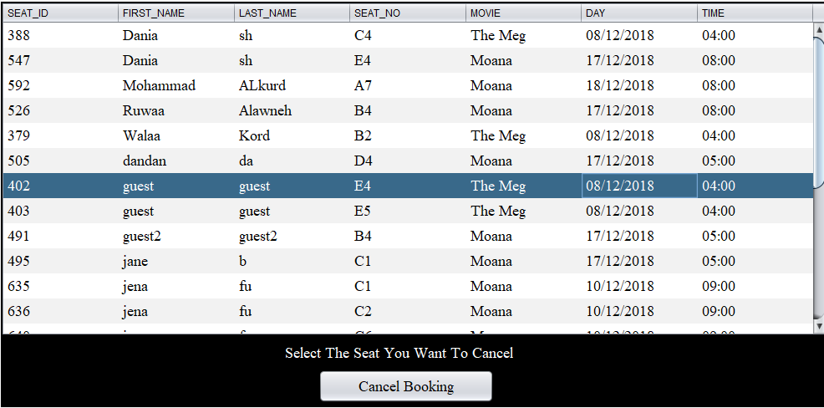

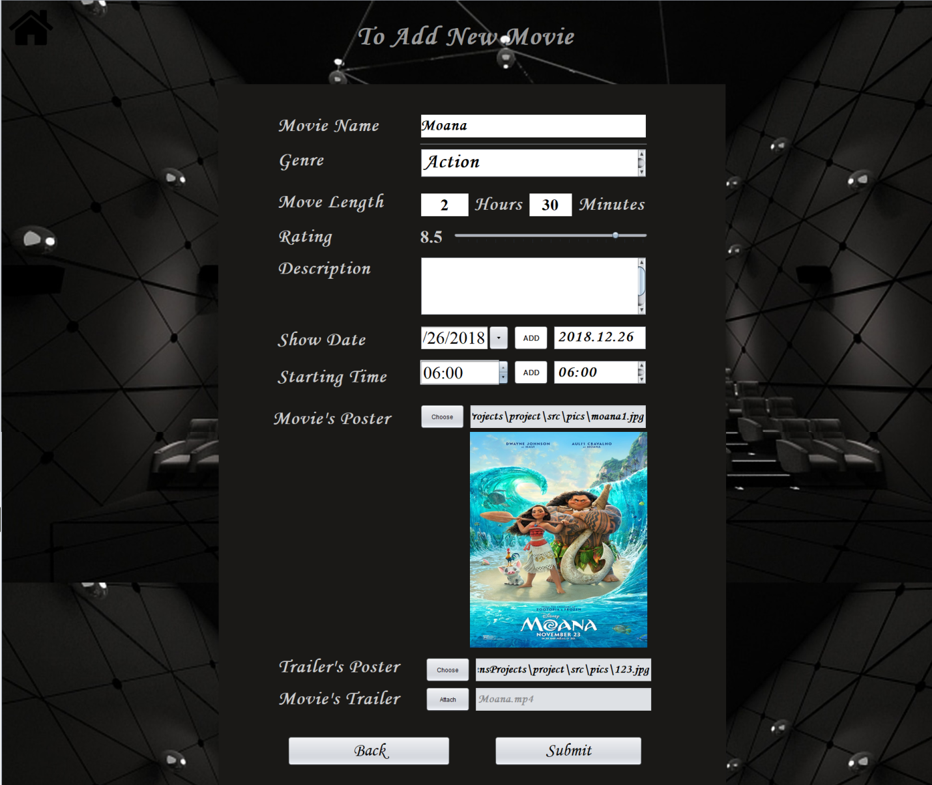

The admin can also get a report for ticket sales, that way they can know which movie had the highest sales, so they could for example add more show times for it.

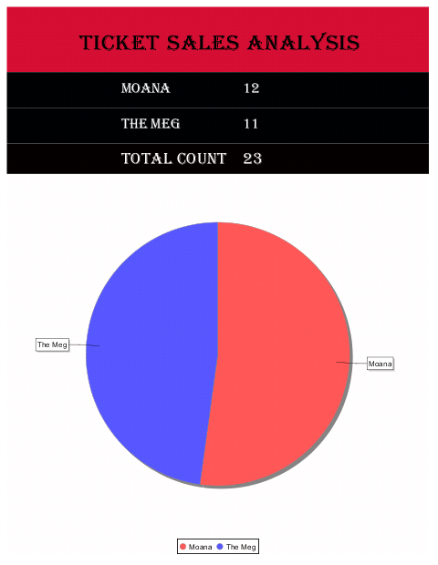

**2. User:**

First the user must sign up then they can easily log in using their email and password.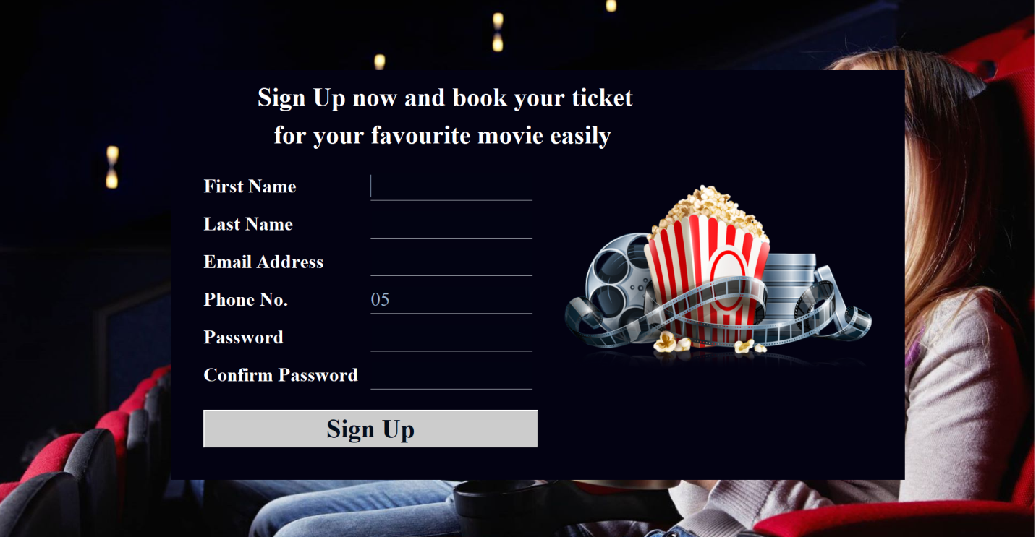

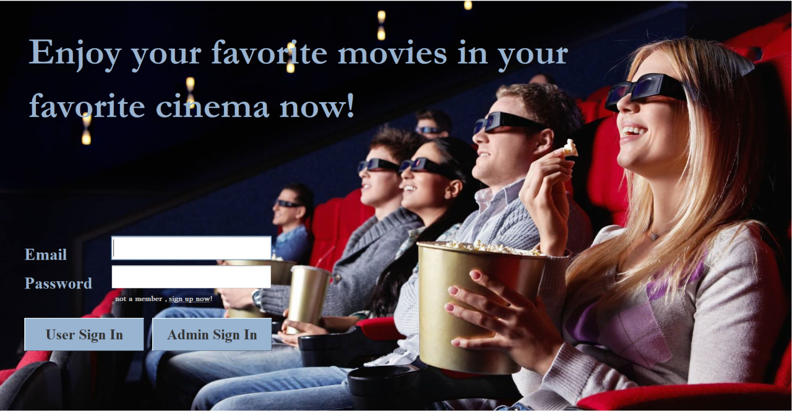

The user can view and cancel any previous bookings if there is any , and they can choose any of the displayed movies where every movie has all the details needed for the user to choose.

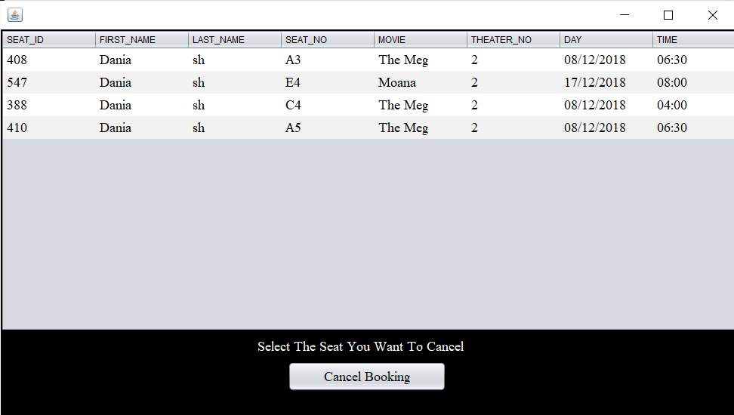

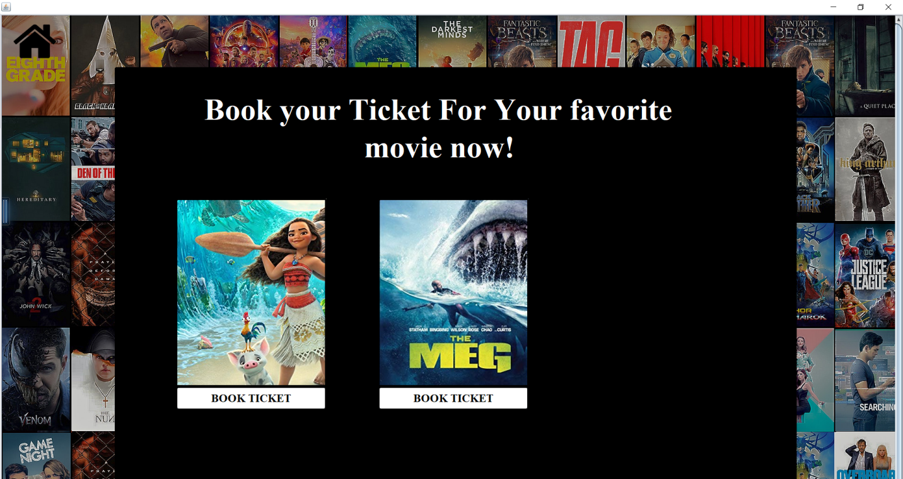

After choosing the movie, the user can pick their most suited time and date from the show times list the admin has provided

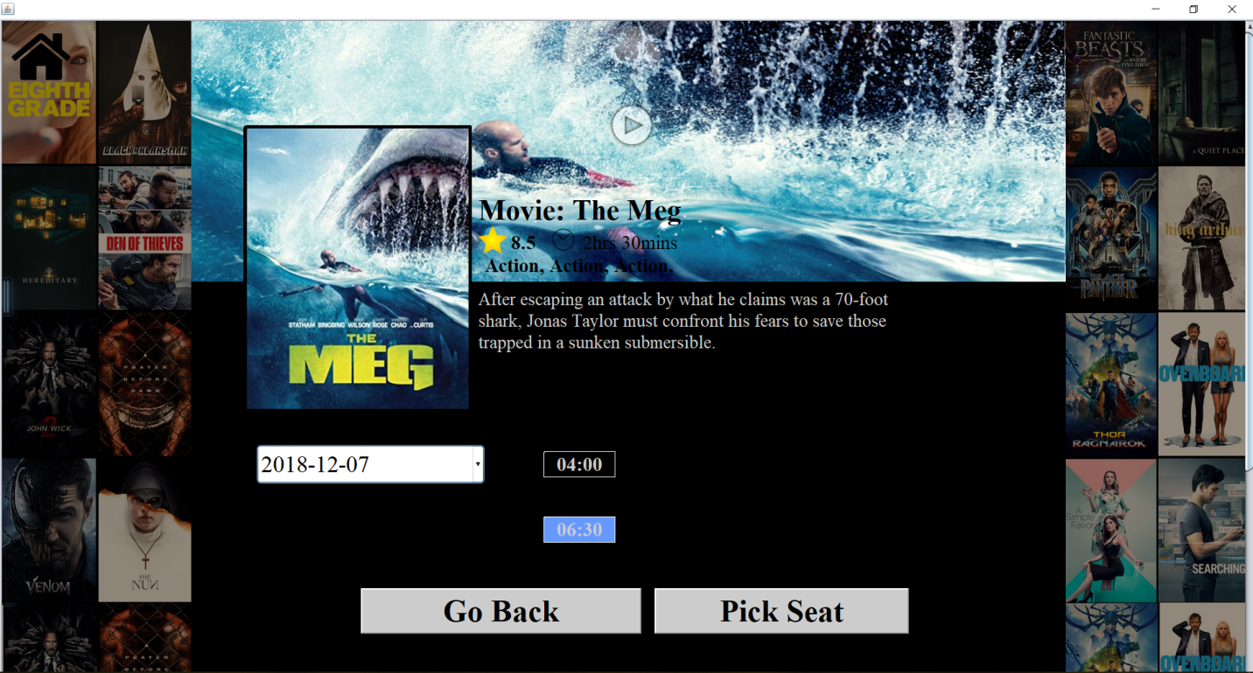

You can also view the movie’s trailer, which we used vlcj library for, the trailer opens in a new frame where you can pause it or forward it easily.

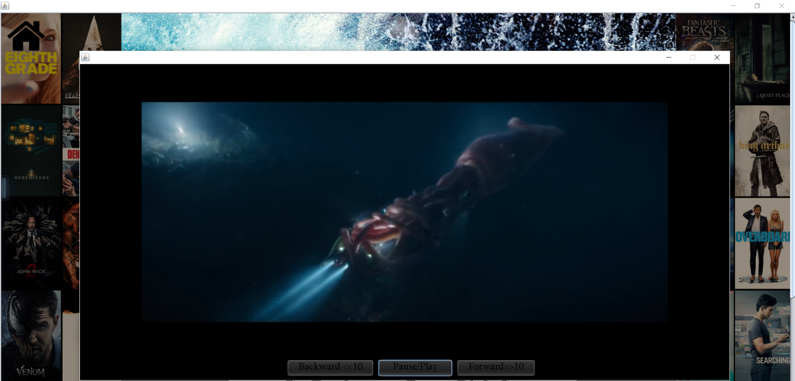

next, after choosing the movie and the time, the user then can pick their favorite seat position, using our friendly interface for picking seats, our program also have the option of choosing gold seats which are more expensive but much more comfortable for the customer, finally the user can view their tickets with all the movie and seat information in them.

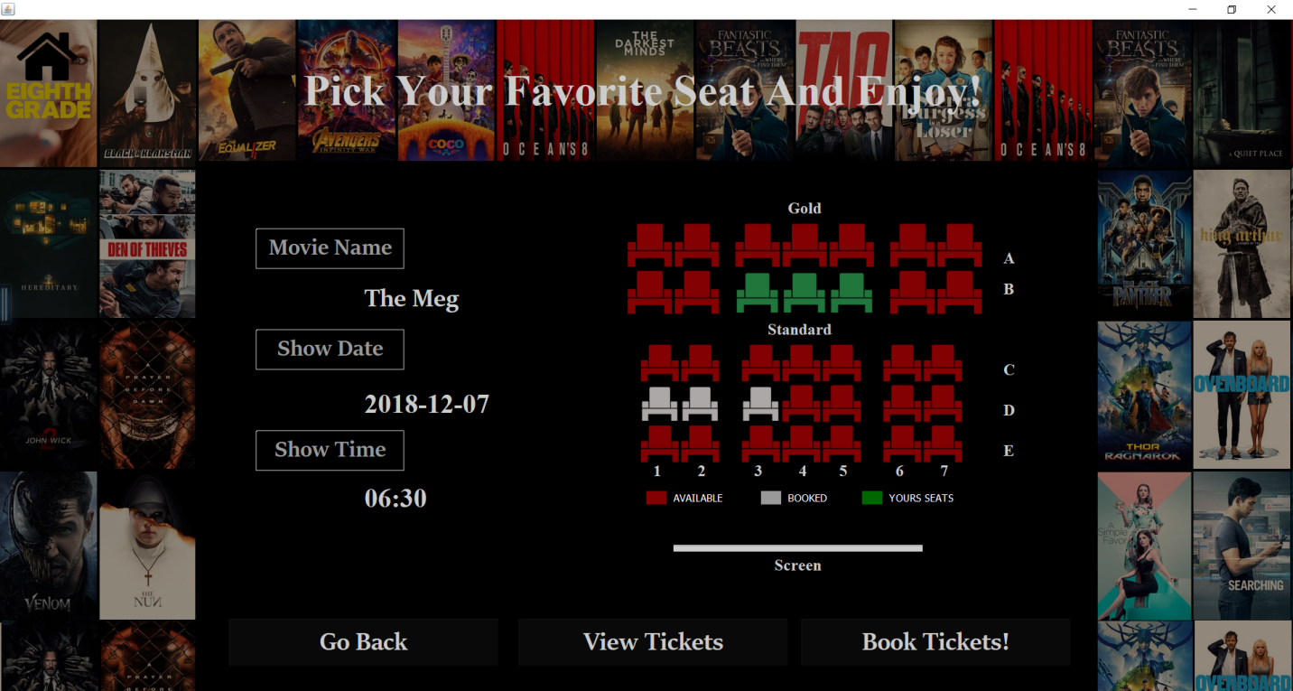

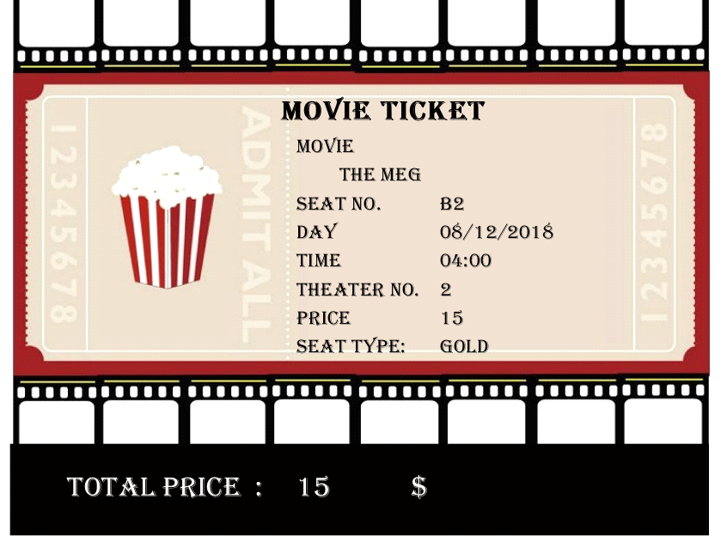

**Conclusion**

This project has been developed successfully and the performance of the system has been satisfactory.

The purpose of this interface GUI is to help users book movie tickets quickly and easily without wasting any time or efforts. Moreover, it provides the admin with a friendly interface that makes it easier and more efficient to manage cinema bookings.